Getting “research ready”: sources of information for academic essays

3 examples of sources/texts from this course. Include the name and author where possible.
1.
2.
3.

Key questions to ask when researching new information
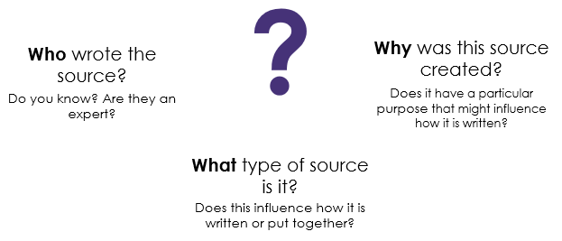
Ranking reliable sources
Rank | Source | Why have I ranked it here?
Red
Amber
Green
Traffic light system: red = least reliable, green = most reliable

