Study Skills 4: Planning Effectively and Time Management
There are lots of things we want to do, need to do and would like to have time for. How do we manage our time so that we get all the essentials done, and even have time for some extras? We have some techniques you can try.
‘Pickle Jar’ Theory
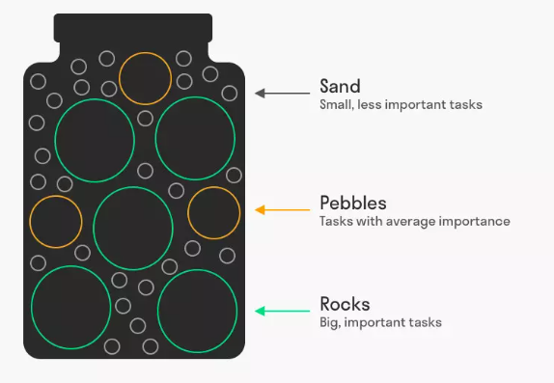
If you have to fit stones of different sizes into a jar, they won’t fit if you put the sand in first. But if you put the rocks in then the pebbles then the sand, there’s enough room.
This theory suggests you should apply the same logic to your time: put in the essential tasks first, then the important tasks, then everything else.
Of course, you have to decide for yourself what is ‘essential’!

Backwards Planning
- Work backwards from your deadlines
- Put the essentials in first
- Estimate how long tasks will take to make sure you start them in good time

Plan your week
Use the grid below to ‘backwards plan’ your week, putting in the essentials first, then the important tasks, then any less important things you’d also like to get done.
Monday | Tuesday | Wednesday | Thursday | Friday

