Study Skills 4: Planning Effectively and Time Management
There are lots of things we want to do, need to do, and would like to have time for. How do we manage our time so that we get all the essentials done, and even have time for some extras? We have some techniques you can try.
‘Pickle Jar’ Theory
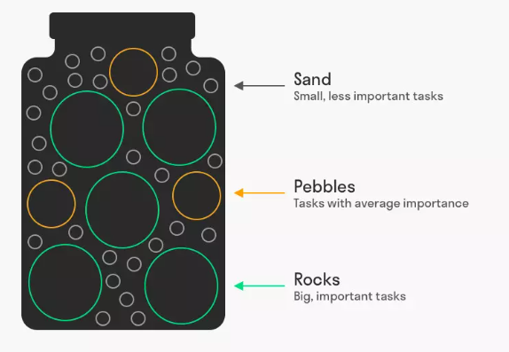
If you have to fit stones of different sizes into a jar, they won’t fit if you put the sand in first. But if you put the rocks in, then the pebbles, then the sand, there’s enough room.
You can apply the same thinking to your time: put in the essential tasks first, then the important tasks, then the other tasks will fit around these.

Planning your week
A good time management strategy is to schedule in time to work on tasks, especially when you are working towards a deadline. Make a list of what you need to do for your final assignment:
- ________________________________________________________________________________

- ________________________________________________________________________________

- ________________________________________________________________________________
- ________________________________________________________________________________
Use the grid below to plan time for these tasks, putting in the essentials first, then important tasks, then any less important things you’d also like to get done. Remember to consider how long each task will take.
Monday | Tuesday | Wednesday | Thursday | Friday

