NIRS Application to a Triathlete

Introduction
Near infrared spectroscopy (NIRS) is an analytical technique that uses the near infrared area of the light spectrum which is between visible and ultra violet light (from 780nm to 2500 nm) [1].
Near infrared light was discovered by William Herschel in the eighteen hundreds, but the first industrial application began in the 1950s. Originally, NIRS was only used as an add-on to other optical devices. Later, developments in light-fibre optics and the monochromator-detector allowed NIRS to become useful in scientific research [1].
There are many industrial uses for NIRS. These include: agriculture. e.g. determining the quality of products; material science. e.g. research into the optical characteristics of nanoparticles; medical and pharmaceutical advances. e.g. brain scans; and industrial uses. e.g. getting accurate C02 consistency [1].
Since 2006, NIRS technology has become more widely used to assess changes in metabolism and oxygenation of muscles. This can be done both during and after exercise in the laboratory and in real-life sports situations. This allows athletes to see where they could improve their muscle use to increase their performance [2].
This essay will explore the design of an NIRS product that measures oxygen levels for a triathlete.

Problem
The NIRS product will be developed for a Great British triathlete, Alistair Brownlee. He is thirty years old and comes from Leeds. He is the first triathlete ever to retain two Olympic gold medals and has completed the Iron Man, a triathlon contest [3].
Alistair will benefit from measuring oxygen levels in his blood because he will know how well his muscles are working. Muscles need oxygen to complete aerobic respiration and a lack of oxygen causes anaerobic respiration, which produces lactic acid, causing muscles to fatigue [4]. Therefore, knowing his muscle oxygen levels will allow him to adjust his training to improve performance. Furthermore, Alistair could measure his readings during a
triathlon, enabling him to adapt his effort both during the event and in subsequent triathlons.
A standard Olympic triathlon consists of 1.5km of swimming, 40km of cycling and 10km of running [4]. As a triathlon consists of swimming, cycling and running, any device designed for Alistair would have several specific requirements. These include being waterproof; compact; durable; lightweight; and reliable and not falling off when his wetsuit is removed.

Ideas
A common method to measure oxygen levels is through the use of pulse oximetry. Like NIRS it is non-invasive. An example device is the finger pulse oximeter, which, when in use, is attached to your finger and instantly gives an oxygen reading from your blood [5]. However, the reading is only of the oxygen level in your blood, not directly in the skeletal muscle. In addition it does not measure metabolism.
NIRS is a superior technology in the fact that it is possible to measure the oxygen saturation level in specific muscles not just in the blood and NIRS also can measure metabolism. In addition, NIRS can be placed anywhere, not just on the end of your finger.
The next important factor to consider is how the NIRS device should be attached to the triathlete design. For instance, the device could be integrated into the clothing or could be a wearable device using a strap to keep it in place. As triathletes predominantly use their legs, the near infrared light needs to be applied onto the legs. It could also be beneficial to measure oxygen in the arm.
An obvious design is to use small, sticky pads to attach the NIRS device to a leg muscle. However the stickiness would likely fail because the water would reduce stickiness when swimming. Also moisture from sweat would have a similar effect possibly resulting in the device being lost. This problem could be overcome by strapping the device onto the thigh, however, this may be uncomfortable.
The next key factor to consider is how the data will be transmitted and stored. It would be useful to send the data long range to a main processing unit which would store the data in the cloud for experts to analyse. However given that it is likely that multiple NIRS devices would be required, for example on the legs and arms: it would be inefficient for each NIRS device to send it's data remotely. Therefore, the wireless NIRS devices need to send data to a small, local computer such as a smartphone or watch. This would also allow the athlete to access the important data in real-time.
The final factor to consider is how the data will be used. The data needs to be analysed offline by experts so that a new training regime could be created for the athlete based on the data. However, the triathlete will want to monitor their oxygen levels during exercise so that the athlete can adapt their effort levels during the event. This could be achieved through creating a smartphone application [Fig. 1].
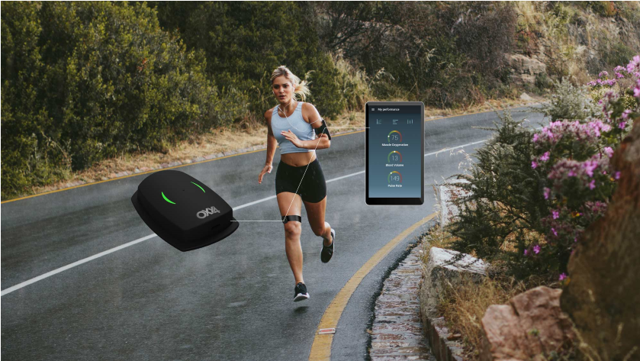
Fig 1: [6] An existing NIRS muscle oxygen level monitor combined with a linked smartphone application.
Plan
The device is called ‘TriView’ because you can view your muscle oxygen levels and metabolism in all the three sports in a triathlon (running, cycling and swimming).
To address the problem of attaching multiple devices, a trisuit (which is what most triathletes wear when completing a triathlon [7]) will be modified to contain the NIRS devices, in both the legs and arms, ensuring that it would not fall off when swimming.
As the NIRS devices are located directly on the limbs, the near infrared light does not need to travel anywhere, hence there would be no need for optical fibres. In addition, there is a
small Bluetooth device inside the NIRS devices so that the data can be directly transferred to the Display Pad. As the data is not being transmitted long-distance, not much power would be consumed during this process, hence only a small battery will be required.
The NIRS device requires a light source, sending light into the tissue. This is achieved using a single-colour green LED because the single colour is easier to process. A laser would be not be used as it is potentially harmful and would use too much power.
The NIRS devices must also contain a spectrometer which would separate the scattered light [8]. In addition, a photodiode muse be included and is required to convert the light waves into electrical currents so the data can be transmitted [9].
The second main component of the TriView device is a computer comprising of a data display; a large, highly flexible screen which would be integrated into the arm of the trisuit. The computer also consists of a Bluetooth receiver (to collect data from the NIRS devices) and also a 4G transmitter[10], to transmit data to the cloud.
The computer and display would be integrated onto the trisuit to make it secure. The display will show real-time data of the oxygenation and metabolism allowing Alistair to see his readings during a triathlon enabling him to adapt as necessary during the event [Fig. 2]. The the display pad (computer and display) and NIRS devices would have to be waterproof.
Analytics
Cloud
Display Pad
G Transmitter
4
/
Bluetooth Reciever
Graph display
Battery
NIRS detector
Bluetooth
Transmitter
Fig. 2:
The TriView product
Both the NIRS devices and computer unit would have to be made out of carbon fibre, because it is lightweight [11]. However, it would be very expensive, at $10 a pound [12]. Carbon fibre is not waterproof [13] therefore an outer layer, such as a plastic coating, would have to be applied.

Do
Multiple engineers of different disciplines would be required to create the TriView product. For example, a software engineer would be required to create the software for the small computer and the analytics. A biomedical engineer would design and implement the NIRS devices, whilst a material engineer would be required to develop the trisuit and waterproof casing.

Improve
The device could be refined in many ways. One issue is the effect of sweat on NIRS data therefore the data is less accurate for high intensity work-outs [14]. This could be improved by adding sweat collecting areas around the small devices in the trisuit. Another way to solve the problem is introducing indocyanine green dye. This has to be applied through an injection so it could be applied before training. The dye improves light scan results which could help for high intensity work-outs [15].
The device could also be improved by adapting the device for other athletes for example a skier. Although, this could be challenging as the design may not work in colder temperatures.
As power may fail, an electrical dynamo could be implemented, using the athlete’s kinetic energy to power the devices or recharge the batteries [16].

Conclusion
NIRS is an analytical technique and is beginning to be applied in sports science. There are problems with measuring oxygen levels for triathletes but if these were resolved, the triathletes would be able to measure oxygen levels in their blood so they know how well their muscles are working.
There are quite a few ways the device could be made; with straps or even as a watch but as the triathletes swim, some small devices integrated into a trisuit are best. The device has been designed to be lightweight, durable, reliable and also waterproof and so should be ideally suited for a triathlete.
References
- Wikipedia, ‘Near-infrared Spectroscopy’, https://en.wikipedia.org/wiki/Nearinfrared_spectroscopy [20 May 2018]
- Perrey S, Ferrari M, ‘Muscle Oximetry in Sports Science: A Systematic Review.’, PubMed (https://www.ncbi.nlm.nih.gov/pubmed/29177977) [March 2018]
- British Triathlon, ‘Alistair Brownlee’,
‘https://www.britishtriathlon.org/gb-teams/elite-team/athletes/alistair-brownlee_56’ [20 May 2018]
- British Triathlon, ‘What is a triathlon’, https://www.britishtriathlon.org/getinvolved-what-is-triathlon’ [20 May 2018]
- Nonin Medical, ‘What is Pulse Oximetry?’, ‘http://www.nonin.com/What-is-PulseOximetry’ [3 June 2018]
- Oxy4, 'Non-invasive performance diagnostics', 'http://www.oxy4.com/en’ [30 May 2018]
- Cycling Weekly, ‘Triathlon suits, everything you need to know’,
‘http://www.cyclingweekly.com/group-tests/triathlon-suits-350298’ [3 June 2018]
- Wikipedia, ‘Spectrometer’, ‘https://en.wikipedia.org/wiki/Spectrometer [3 June 2018]
- Wikipedia, ‘Photodiode’, ‘https://en.wikipedia.org/wiki/Photodiode’ [3 June 2018]
- Wikipedia, ‘4G’, ‘https://en.wikipedia.org/wiki/4G’ [3 June 2018]
- Wikipedia, ‘Carbon fiber reinforced polymer’,
‘https://en.wikipedia.org/wiki/Carbon_fiber_reinforced_polymer’ [3 June 2018]
- How Stuff Works, ‘Can carbon fibre solve the oil crisis?’,
‘https://auto.howstuffworks.com/fuel-efficiency/fuel-economy/carbon-fiber-oilcrisis2.htm’ [3 June 2018]
- Quora, ‘Is Carbon Fibre waterproof?’, ‘https://www.quora.com/Is-carbon-fibrewaterproof’ [4 June 2018]
- Youtube, ''How it works: NIRS for determining oxygen use',
'https://www.youtube.com/watch?v=d41Zt0by-oY' [4 June 2018]
- Wikipedia, ‘Indocyanine green’,
‘https://en.wikipedia.org/wiki/Indocyanine_green’ [3 June 2018]
- BBC, ‘Dynamo power to recharge handsets’,
‘https://www.bbc.co.uk/news/10224363’ [6 June 2018]

