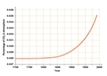

about 7 trillion tons of water per year intothe atmosphere via evaporation (Moutinho & Schwartzman, 2005). This stabilises the atmosphere and helps to keep the climate humid and rainy. If we cut down forests, we are losing that stability as well as emitting carbon dioxide to warm the planet. Therefore, we can see that deforestation contributes to climate change and humans are causing this. This means that our actions can change the climate.

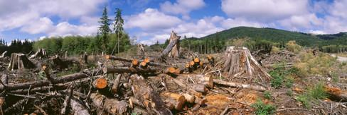

Figure 4 - This picture shows a deforested landscape.

Another factor which supports the topic of human induced climate change is the burning of fossil fuels since the industrial revolution. Since the industrial revolution, we have needed coal, oil and gas to power the machinery invented. Burning these solids emits the two main greenhouse gases, CO₂ and CH₄, into our atmosphere (figure 6).

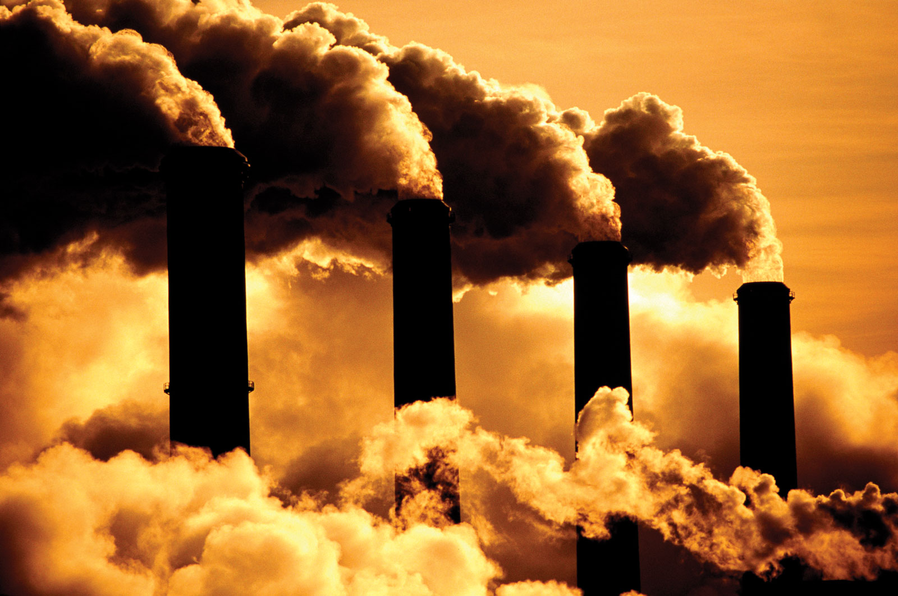

Figure 5 - This picture shows our factories releasing gases into our atmosphere.

These gases absorb the heat from the sun and re-emit it back towards the earth’s surface, resulting in the climate getting warmer. For example, a graph from BBC Bitesize (figure 7) shows how much CO₂ was emitted into the atmosphere between 1700 and 2000. It shows a rapid rise of the amount emitted since 1850 – near the end of the Industrial Revolution. On another graph from the BBC (figure 6), it shows that the temperature rises with the carbon dioxide and the two factors start to do so at the same time. As mentioned previously, this is at the end of the Industrial Revolution where we needed to power electricity and heating, burn fossil fuels at facilities for energy and use fuel for transport. It is said that avoiding dangerous climate change will require a rapid transition away from fossil fuels (Erickson & Lazarus, 2017) as the gases we are releasing are not stabilizing our atmosphere and keeping the correct percentages of each gas where they need to be. To that end, it is easy to see that the burning of fossil fuels such as CO₂ and CH₄ contributes to climate change.

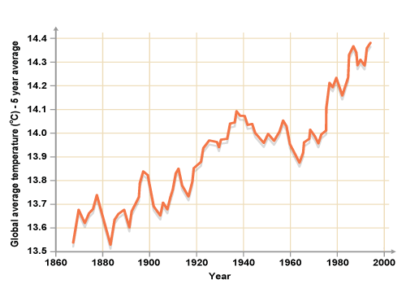

Finally, another factor of human induced climate change is the number of Chlorofluorocarbons (CFCs) that we were releasing into the atmosphere. CFCs are chemicals found in spray aerosols, air conditioners and refrigerators. They can change our climate by reacting with gases in our atmosphere. In the lower part of the stratosphere, there is something called the ozone layer. This layer is what absorbs most of the sun’s ultraviolet radiation to stop it coming down to the earth’s surface where it can harm animals and humans. When these CFCs reach the upper atmosphere and are exposed to ultraviolet rays, they break down into substances that include chlorine then react with the ozone in the ozone layer and begins to break it down. This allows more heat to reach the surface of our earth, warming our planet. It is feared that the

ozone layer is deteriorating due to the release of pollution containing the chemicals chlorine and bromine (National Geographic, 2015) which are chemicals found in the human resources listed above. In some places the ozone layer has deteriorated by about 20% (National Geographic, 2015). This acts as a factor of climate change as earth’s surface is exposed to more heat and we can see this by comparing the temperature and CFCs emissions. CFCs were banned in 1996 but they still impact us by raising your carbon footprint (Scientific American, A Division of Nature America, 2017) A study shows that during the increasing phase of CFCs, trends in temperature are also increasing (Revadekar & Patil, 2011) and that the conclusion of this study is that the variation in surface air temperature indeed has a certain link with the changes in CFCs (Revadekar & Patil, 2011). Consequently, we can identify that CFCs contribute slightly to climate change.

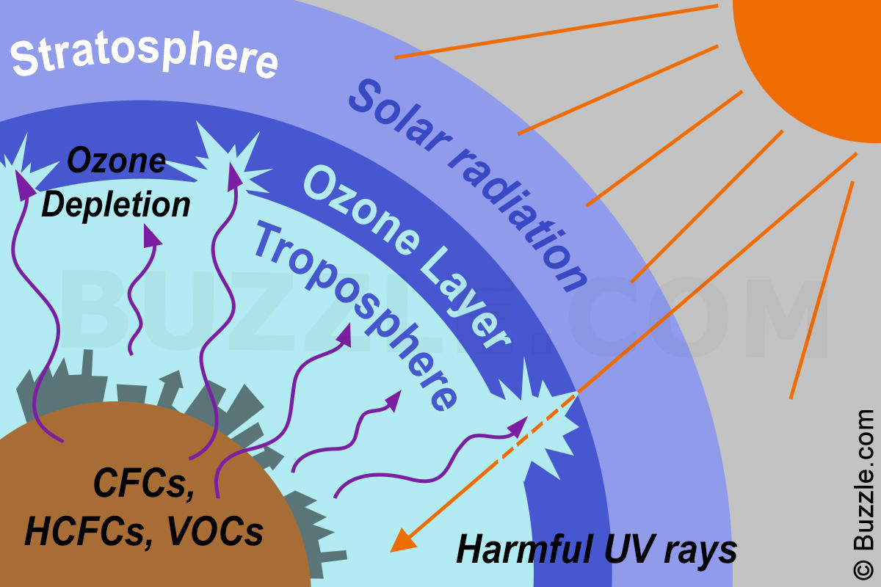

**Conclusion**

Many people have different opinions and views on the statement, “the climate has always been changing, so humans cannot possibly be responsible for the current climate change.” Some people agree and believe that climate change is mostly natural whereas others disagree and think that it is mostly human induced. Based on the evidence that I have discussed, in my opinion, I believe that climate change is partly due to natural causes, such as volcanoes, orbital changes and ocean currents, however I think that it is mostly human induced. The most important piece of evidence that reveals this to me is the hockey stick graphs that show how the burning of fossil fuels emit CO₂ and CH₄ into the atmosphere and absorb the suns radiation and re-emit it back towards the earth’s surface. For me, the evidence of multiple graphs and statistics show that the temperature is rising with the levels of atmospheric greenhouse gases and the time of the significant rise corresponds to after the industrial revolution when we needed to start burning fossil fuels.

**The climate has always been changing, so humans cannot possibly be responsible for the current climate change. Discuss.**

**Introduction**

Some people, including some scientists, believe that “the climate has always been changing, so humans cannot possibly be responsible for the current climate change.” The climate shows how the atmosphere is changing over a long period of time. It is the average of the weather which is the conditions in the atmosphere over a shorter period of time. The climate is changing over time (figure 1) and there are many reasons for this.For example, Earth has experienced ice ages in the past, such as the Karoo Ice Age 360 – 260 million years ago, where the climate cooled dramatically. Some people consider the climate change to be completely natural whereas others think that it is human induced and what we do every day has an impact on it. In this essay, I will be discussing different factors of climate change and weighing up and comparing both natural affects and human induced affects.

Figure 1 - This graph shows how the average global temperature has risen between 1860 and 2000.

**Climate has always been changing naturally**

On the one hand, some people agree with the statement “the climate has always been changing, so humans cannot possibly be responsible for the current climate change.”

One way to prove this is to study the ocean currents. Due to the continents, the ocean has to travel and channel down to different places. This results in ocean currents. These currents are determined by the density and the temperature and change the speed meaning that the quantity of heat transported to different locations can vary. For example, the oceans absorb twice as much of the sun’s radiation as the atmosphere or land surface (Rahmstorf, 1997) meaning that however cold or hot our climate is depends a lot on the oceans.

Another way the climate is changing naturally is the Earth’s orbital changes; precession, eccentricity and obliquity (figure 3). Precession is the direction of the Earth’s tilt, eccentricity is the shape of the Earth’s orbit and obliquity is how much the Earth tilts. Today, we are at the point of precession where we are nearest to the sun in winter and further away during summer. This is constantly changing very small amounts over time. It changes our climate as the position

of precession would be expected to cause less severe seasons—and that is what we may be experiencing now as the winters are warmer, and the summers are not markedly hotter (Purdue University, 2014). In a graph from the National Oceanic and Atmospheric Administration (NOAA), the peaks and troughs of temperature matches the peaks and troughs of the amount of solar radiation received in one area (insolation) which changes due to the precession, obliquity and eccentricity. To that end, it is clear to see that the climate is changing partly due to orbital changes.

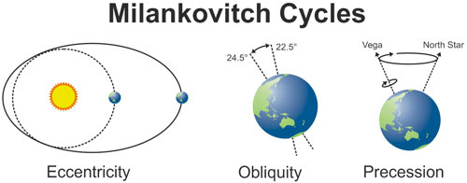

Figure 2 - These pictures show the meanings of the Milankovitch Cycles: Eccentricity, Obliquity and Precession.

Climate can also change due to volcanic eruption. Volcanos release large quantities of ash and gas when they erupt (figure 4). This blanket of thick chemicals clouds the atmosphere and can block out energy from the sun. Sulphur dioxide is released during these eruptions and the particles formed from this reduce the amount of solar radiation that reaches the Earth’s surface causing the climate to cool. The British Geological Survey say that the volcanic dust’s effects may warm or cool the Earth’s surface, depending on how sunlight interacts with the volcanic material. Just over 200 years ago, April 1815, Mount Tambora in Indonesia erupted. Its ash cloud shot over 20 miles high reaching the stratosphere and quickly spread around the world absorbing sunlight. The average temperature was said to have dropped 3 degrees Celsius which had a big impact on the Northern hemisphere. It led to there being frost in summer and much more rainfall than average which resulted in crop failures. Therefore, it is clear to see that volcanic eruptions can have an impact on climate change whether they are making it warmer or colder.

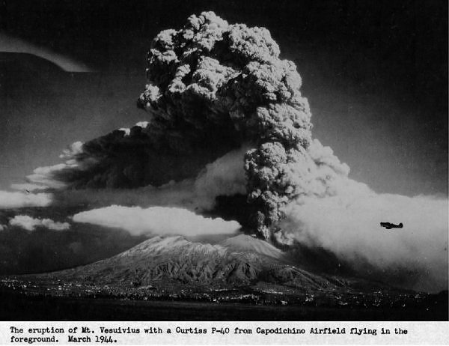

Figure 3 - This picture shows a Mount Vesuvius releasing gases into air.

**Human Induced Climate Change**

On the other hand, some people disagree with the statement which says that “the climate has always been changing” and believe climate change is human induced.

One of the factors causing human induced climate change is deforestation. Trees and plants naturally store carbon dioxide (CO₂) for photosynthesis and when they are cut down (Figure 5), that CO₂ is released into the atmosphere raising the atmospheric levels of this gas. When the sun’s energy reaches the Earth’s surface, it reflects off it and bounces back into space. However, when there are more greenhouse gases in our atmosphere like CO₂, the heat is trapped in, warming our atmosphere. For example, just tropical deforestation alone is estimated to have released 15-35% of annual carbon dioxide emissions during the 1990s (Moutinho & Schwartzman, 2005). Overall, it is estimated that 3.3 billion tonnes of carbon dioxide were emitted into the atmosphere in 2011 due to deforestation (What’s Your Impact?, 2018). CO₂ is not the only climate interaction that forests have. They also produce water vapor. For example, the Amazon pumps

Figure 8 – This picture shows the layers of the atmosphere and ozone depletion.

Figure 7 – This graph shows the rise of atmospheric CO₂ since 1700.

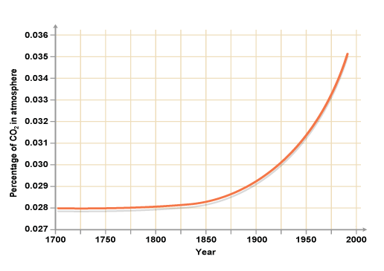

Figure 6 – This graph shows a rise in temperature since 1860.

**Reference List**

BBC Bitesize (2014): The environment, the Earth and the universe: Changes in the environment [Online]. Available from: <http://www.bbc.co.uk/bitesize/ks3/science/environment_earth_universe/changes_in_environment/revision/6/> [Accessed 28.4.2018].

The British Geological Survey (2017): What causes the earth’s climate to change? [Online]. Available from: [www.bgs.ac.uk/discoveringGeology/climateChange/general/causes.html](http://www.bgs.ac.uk/discoveringGeology/climateChange/general/causes.html) [Accessed 28.4.2018].

Erickson & Lazarus. (2018) Climatic Change. Springer Netherlands.

The Guardian (2012): Environment: Guardian Environment Network [Online]. Available from: <https://www.theguardian.com/environment/2012/oct/16/daily-mail-global-warming-stopped-wrong> [Accessed 28.4.2018].

Moutinho & Schwartzman. (2005). Tropical Deforestation and Climate Change. 132 p.

National Geographic. Ozone Depletion [Online]. Available from: <https://www.nationalgeographic.com/environment/global-warming/ozone-depletion/> [Accessed 28.4.2018].

National Oceanic Atmospheric Administration (2014): Milankovitch Cycles [Online]. Available from: <https://www.climate.gov/teaching/resources/milankovitch-cycles> [Accessed 28.4.2018].

Purdue University. (2014). Milankovitch Cycle Case Study. 11 p.

Rahmstorf. (1997). Ocean Currents and Climate Change.

Revadekar & Patil. (2011). ‘On the surface air temperature variation in relation to chlorofluorocarbons over the Indian region’. Atmospheric Environment, 45.

What’s Your Impact? (2018). Greenhouse Gases: Carbon Dioxide Emissions [Online]. Available from: <https://whatsyourimpact.org/greenhouse-gases/carbon-dioxide-emissions>